Development Diary

For this project, you must complete the following tasks in the order that they are described:

1. From the problem description, create a list of all classes that you can identify. For each

class, list the associated data member variables and identify an initial set of member

functions.

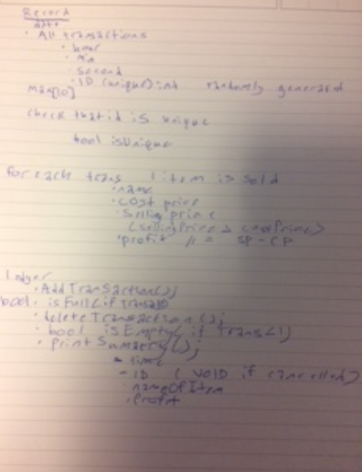

"transaction.hpp" – trancasction(hour,min,second,id,bool isUnique), item(name, cost, elling, profit, ID)

"ledger.hpp addTrancaction(); deleteTrancaction(); isFull(); isEmpty(); printSummary();

2. List out a set of steps that you will take to implement your solution to the problem. Each

step refers to an increment of the program that you will be creating. It is recommended to

complete the implementation of a single logical action per step.

* Create a Ledger
  + The ledger will have 3 methods
    - addTransaction
    - voidTransaction
    - printSummary
* Create Transaction
  + Methods
    - Contructor creates new transaction
    - Call all transactions
    - updateTransactions
* Fill in ledger methods
* Fill in transaction methods
* Max out transaction at 10
* Allow transaction to be sorted

3. Begin implementing your program by using the plan that you created in step 2. For each

step, save a snapshot of your program design once that step is completed. Each snapshot

should be saved to its own directory so that you can go back to any version directory, should

you encounter problems.

4. Once you have finished implementing your solution, reflect on the process that you

followed. Did you wind up with the same classes as you initially identified? Did you need

to change any of the functionality or add unexpected details? Did you have to deviate from

your plan? Write a description of any details that needed to change as you worked on your

solution.